**The simulation of LDPC**

This is our second group-homework. You need to finish the homework with your group members. Note that the number of members in each group is the same as the first group homeworks.

1. Please use MATLAB to simulate the decoding algorithm of LDPC, namely, bit flipping (BF) decoding algorithm. In the simulation, you need to do as follows.
2. Generate a parity check matrix of LDPC with size $256×512$.
3. Use the BF algorithm to decode a codeword generated by using 1).
4. Give the bit error probability of your decoding algorithm when the SNR is 1, 1.5, 2, 2, 5, 3 dB with BPSK modulation and AWGN channels.

Note:

1. you can use a codeword with all zero entries, e.g., a codeword c=(0,0,0), to avoid encoding process.
2. In the practical scenario, the codeword should be modulated before transmitting to the physical channel. In our homework, you need to modulate the codeword by BPSK, which maps 1 to -1 and maps 0 to +1. For example, for a codeword $c=(1,0,1)$, it becomes $v=\left(-1,1,-1\right)$ after BPSK modulation.
3. The physical channel in our homework is AWGN channel, where the probability density function of noise follows Gaussian distribution $N(0,σ^{2})$. It means that the received vector is $y=v+n$, where $n$ is a noise vector whose every entry follows the above Gaussian distribution.
4. The SNR is denoted as

$$SNR=10log\frac{p}{σ^{2}}dB$$

where $p$ is the power of signal. In the simulation, for convenience, let the power of signal be 1. It means that the received vector is

$$y=v+{σn}^{'}$$

where $n^{'}$ follows the standard Gaussian distribution $N(0,1)$.

1. Before the decoding, you need to demodulate the received vector $y=(y_{1},…,y_{n})$ as follows. If $y_{i}>0$, we set it to be 0, otherwise, it is 1. For example, for a received vector $y=(-0.2,0.1,2)$, you need to demodulate it as $y^{'}=(1,0,0)$.
2. You need to use the vector after demodulation to finish decoding process and obtain the decoding output $c^{'}=(c_{1}^{'},…,c_{n}^{'})$. For example, you need to use $y^{'}=(1,0,0)$ to do decoding and obtain the final decoding output.
3. For a codeword $c=(c_{1},…,c_{n})$ and the corresponding decoding output $c^{'}=(c_{1}^{'},…,c_{n}^{'})$, the bit error probability can be defined simply as

$p=\frac{the number of error bits}{the total number of bits}$

1. Please write a report according to your experiments. Note that in your report, you need to include the following contents:
2. The contributions of different members.
3. Some important codes for your experiments.
4. Theoretic analysis.
5. The results of your experiments.

Note：

1. You need to submit the second group homework with electronic edition to

itct_sjtu@163.com.

1. Deadline is December 30.

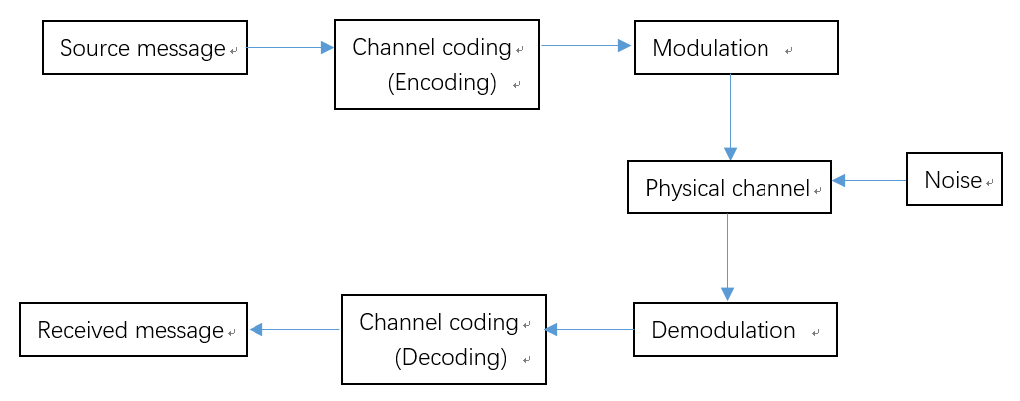

A simple digital communication system